Krokodil hype: Is toxic 'flesh-eating' street drug in Canada?

Reports have surfaced, but there are no confirmed cases of addictive homemade heroin substitute
By Janet Davison, CBC News Posted: Nov 25, 2013 5:00 AM ET Last Updated: Nov 27, 2013 4:43 PM ET
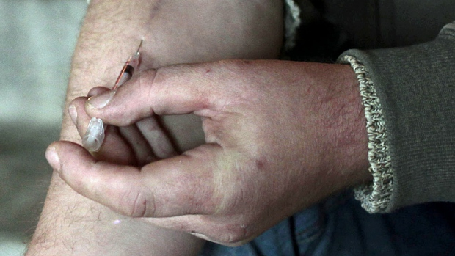
Users of intravenous drugs can develop infections around the injection site that could be mistaken for symptoms associated with krokodil, a homemade substitute for heroin. (Reuters)
If headlines in the past few weeks are to be believed, a "Flesh-eating 'zombie' drug" that could devour users "from the inside out" is finding its way onto American streets. Then came reports suggesting that "krokodil," a cheap and highly addictive homemade substitute for heroin that surfaced first in Russia about 10 years ago, had appeared in Ontario's Niagara region.
But so far, neither the U.S. Drug Enforcement Agency nor Health Canada has identified krokodil, also known as desomorphine, in any samples they've analyzed since the DEA found two instances of it in 2004.
'When you have new drugs like this, it's very difficult to get a sense of their presence early on.'- Matthew Young
And police in Niagara are now saying the reported cases of the drug — an ugly concoction of codeine mixed with common products such as gasoline, lighter fluid, paint thinner or industrial cleaning oil — haven't been medically confirmed.
Krokodil is named for the Russian word for crocodile and its tendency to turn users' skin rough and scaly. The injectable opioid can cause brain damage and severe tissue damage, sometimes leading to gangrene, amputations and even death. It has also been linked to pneumonia, blood poisoning, meningitis, liver and kidney problems, rotting gums and bone infections.
The horrific health problems the drug has caused among the well over 100,000 users in Russia and Ukraine have been well documented by researchers in publications such as the International Journal of Drug Policy. But so far there is no solid, official proof that krokodil has reached Canada.
The recent news reports about the drug coupled with the lack of hard evidence to back them up underline how difficult it is for health and law enforcement officials to keep up with the evolving mix of street drugs.
"When you have new drugs like this, it's very difficult to get a sense of their presence early on," says Matthew Young, a senior research and policy analyst at the Canadian Centre on Substance Abuse in Ottawa.
The drugs are too new to be asked about in surveys, and so attention turns to whether there have been seizures or samples confirmed in labs. And then, suggests Young, people consider any anecdotal information that may be circulating.

'A lot of hype'
"New drugs tend to have come along with a lot of hype attached to it, especially when there are images like there are out there on the internet that are associated with [krokodil]," Young says.
In this case, the images and videos posted online out of Russia are disturbing, showing krokodil users suffering everything from gaping lesions to exposed bone.
"The harms associated with krokodil are extreme and unprecedented," say the authors of a report that appeared in the International Journal of Drug Policy earlier this year.
But when it comes to definitive proof from official channels that the drug is actually on the street on this side of the Atlantic Ocean, there is none.
In the U.S., where the headlines about krokodil have been almost apocalyptic, the DEA is "very concerned about the possible appearance" of the drug, special agent Joseph Moses said in an interview from Washington.
"But to date, none of our forensic laboratories has analyzed an exhibit found to contain desomorphine."
A sample sent recently to the DEA's forensic laboratory in Chicago turned out to be heroin.
"We get a lot of calls about this … because it's such a gruesome imagery, with the area surrounding the point of injection dying," said Moses. "We have a lot of people who want to call it a trend, but we aren't seeing it."

No samples identified
The DEA did identify two samples as desomorphine in 2004, but have made no similar identifications since then.
In Canada, Health Canada is aware of reports of desomorphine, the department said in an email.
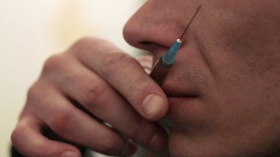
A man checks with his lips the temperature of syringe with heroin injection at a flat in the Russian town of Tver, 170 kilometres northwest of Moscow, on Nov. 13, 2010. Use of krokodil, a substitute for heroin, emerged in Russia about a decade ago. (Reuters)
"To date, Health Canada's drug analysis service has not received any samples that have been identified as containing desomorphine."
Late last week, the Canadian Community Epidemiology Network on Drug Use, which isco-ordinated by the Canadian Centre on Substance Abuse, issued a bulletin noting that there had been "no confirmed reports" of desomorphine in Canada in the past two months.
"It is possible that some unconfirmed reports were made after observing severe wounds at injection sites among intravenous (IV) drug users," the bulletin said.
While krokodil has been on the centre's radar screen, Young said in an interview before the bulletin was issued that he was skeptical of reports it had surfaced in Niagara.
"I don't see the motivation there for opioid users to go towards a dirtier, even less safe alternative to what they currently have."

More reports
In Niagara, word of krokodil surfaced about a year ago at AIDS Niagara, through its StreetWorks outreach and harm reduction program that works with drug users.
StreetWorks co-ordinator Rhonda Thompson says a woman came into their offices and "was very adamant" that she had seen krokodil in Niagara.
"You kind of have to take these things with a grain of salt. It was only one report from one client."
Then about three weeks ago, another person came into their office and said two people were in a Niagara Health System hospital because of the effects of injecting krokodil.
Another person also turned up at the StreetWorks' Niagara Falls office and, Thompson says, showed their nurse wounds on his arm that weren't abscesses "like we're used to seeing.
'Maybe these are just old-fashioned staph infections — who knows — but it certainly needs to be looked at.'- Rhonda Thompson
"It's more like they're ulcers that go deep into the soft tissue," says Thompson.
"He said it felt like burning, and his symptoms started to develop a week after he started using this particular purchase of heroin. He thought he was buying heroin and he's never had any experience ... in the past where these sorts of ulcers and lesions were happening."
In a separate interview with CBC Radio's As it Happens on Friday, Thompson said there have been about a dozen cases of unusual wounds and "pretty significant" soft tissue damage among drug users in the region in the past two months.
Thompson spoke with staff at Niagara Regional Police (NRP), who issued a public statement that krokodil had been reported in Niagara Region. Police later said the reported cases had not been medically confirmed.
The Niagara Health System also said it had no confirmation of krokodil.
"Reports that we have treated patients at the Niagara Health System for conditions related to krokodil are unconfirmed," David Barry, manager of outpatient addiction services at the NHS, said in an emailed statement.
"We will continue working closely with our community partners to ensure we are doing everything we can to educate people about the health risks of using krokodil or other drugs."

Other possibilities
One of problems for the krokodil hunters is that the harm the drug can do to the body can resemble other types of infections or health conditions.
"The symptoms associated with krokodil can be mistaken with the complications that long-term users of injectable drugs like heroin can develop through infections from reusing needles and exposing themselves to all sorts of bacteria," NRP said in a release.
Thompson also wondered if what was observed in Niagara might have been the result of infections not specific to krokodil.
"I find it very hard to believe that little old Niagara would be the only one experiencing this, if this is in fact what it is. Maybe these are just old-fashioned staph infections — who knows — but it certainly needs to be looked at."
Young says he will continue to be on the lookout for any evidence krokodil may be in Canada.
"There's no indication that this drug will not come here. We're keeping an eye out for it. I just think that the conditions aren't really ripe for a drug such as this making its way to Canada," Young says.
"We can't say with any 100 per cent certainty that it's not here either. We can only say we have no confirmed reports."

